Name Date

MD.1

Mathematics Grade 1 Unit 4 Study Guide
Sorting, Comparing, and Ordering

Look at the 3 objects below. Order the 3 objects from longest to shortest.
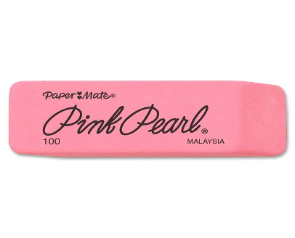
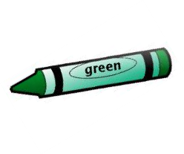
eraser

crayon

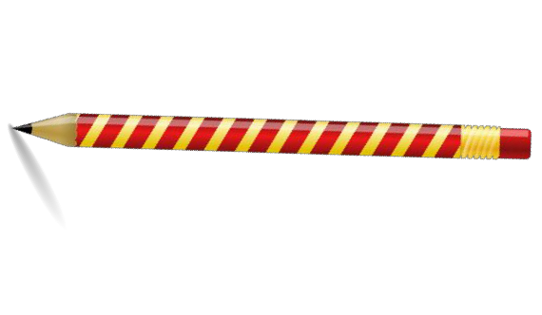
pencil

1.) Longest

2.) ______________________

3.) Shortest_____________

MD.1

Jenny wants to measure an object. What are two different ways that she can measure an object?
4.) 1st Way

_
_ 5.) 2nd Way

MD.1

Use the pictures below to decide if each statement is true or false.
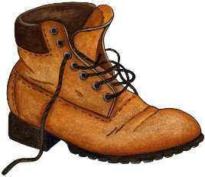
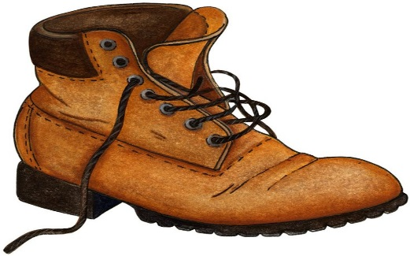
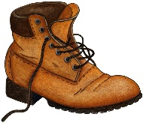

Boot C
Boot B
Boot A

6.) Boot B is longer than Boot A.

7.) Boot C is the longest.

8.) Boot A is the shortest.

MD.2
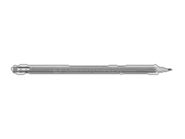
9.) Sam used paperclips to measure the length of his pencil.

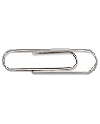

Do you agree that Sam’s pencil is 4 paperclips long? Why or why not?

MD.2
Measure the lines below using cubes.

10.) The line is cubes long.

11.) The line is cubes long.

12.) The line is cubes long.

MD.3

Use the clock below.

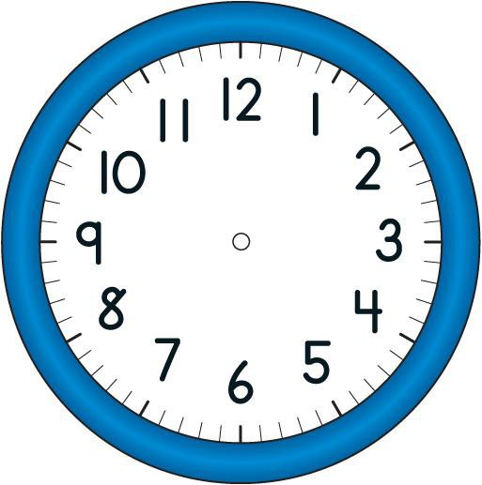
13.) Circle the hour hand.

14.) Place an X on the minute hand.

MD.3

15.) Will’s class went to recess at 11:30. Which clock below shows 11:30?

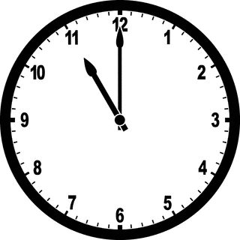
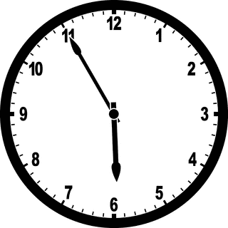
A.) B.)

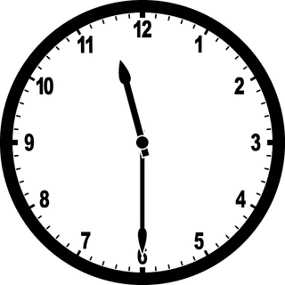
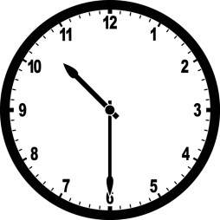
C.) D.)

MD.3

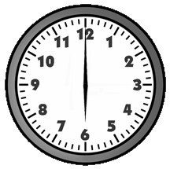
16.) Write the digital times that are shown on the analog clocks.

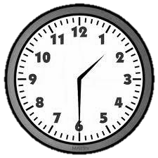

MD.4

Use the table below to answer the following questions.

Our Favorite Times of Day

Morning | IIII I | 6
Afternoon | IIII IIII | 9
Evening | IIII IIII | 10

17.) Which time of the day do the fewest children like?

18.) Which time of the day do the most children like?

19.) How many more children chose evening than morning?

MD.4

20.) How many children answered the question about their favorite time of the day?
  - 17

  - 20

  - 22

  - 25

